
Year 5 – Summer 1
These activities are designed to give you ideas of activities to do at home with your families or independently, to support your learning at school. Please choose three to complete this half term. We can’t wait to see your creativity!
Science  Create a shoebox model showing the life cycle of a mammal, insect, bird, or amphibian (label each stage).  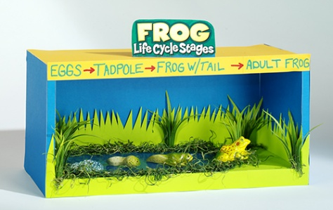 | English -  Create a “Save the Beetles” presentation  You could include:  - why beetles are important  - why they should be protected.  - Include a few facts (e.g. how beetles help the environment)  - your own opinions  - a clear message to persuade people to care about them. | Maths  Decimal Dice Game – Order & Compare  Step 1:  - Roll to Make a Decimal  - Roll the dice 3 times  - Use the numbers to make a decimal:  Example: Rolls: 3, 7, 5 → 0.375  Step 2: Repeat until you have 5 decimal numbers  Step 3: Order Them  Challenge: Can you round them to the nearest tenth | Art/DT  Grow Your Own Food Plan  Design your own mini garden or farm that could grow food successfully.  Remember to think about what grows in each season!
History  Research Project:  ‘Modern China’  This half term, our History Topic is ‘The Shang Dynasty’.  To go alongside this, create a Fact File on ‘Modern China’.  Go to this website…  China Facts for Kids | China for Kids | Geography | Attractions (kids-world-travel-guide.com)  …And find out about:  - Geographical features, traditions, religion, language and culture. | Personal development  In year 5 we will be taking part in an overnight camping trip. Can you write a persuasive letter  to Miss Trott:  “Why I should bring this item to camp”  (e.g. phone, snacks, favourite toy)  Try to use:  - Persuasive language (e.g. “I strongly believe…”, “This is important because…”)  - Emotive language (e.g. “I would feel much safer…”)  - Rhetorical questions (“What if I need it?”) | PE  This half term in PE is cricket.  Can you create a game or activity of your own which practises some of the skills required to be good at cricket?  You could include throwing, catching, batting, bowling or fielding.  Draw and write about your activity and ask a family member or friend to try it with you. | PSHE  This half term, we will be looking at different basic first aid.  Can you practise how to help someone if they are having an asthma attack.  To check the steps please follow this link:  https://firstaidchampions.redcross.org.uk/en/primary/first-aid-skills/asthma-attack/

