
Year 5 – Spring 2
These activities are designed to give you ideas of activities to do at home with your families or independently, to support your learning at school. Please choose three to complete this half term. We can’t wait to see your creativity!
Science  Making Slime – Science Experiment  If you need the method, ask for the slime instruction handout.  Write sentences explaining the observations you made whilst making slime. Can you explain if it is a reversable or irreversible change.  Explain how a new material is made using a science word. | Geography  This half term our topic is Energy- How do we power the world.  Have a go at making your own edible gummy greenhouse gasses.  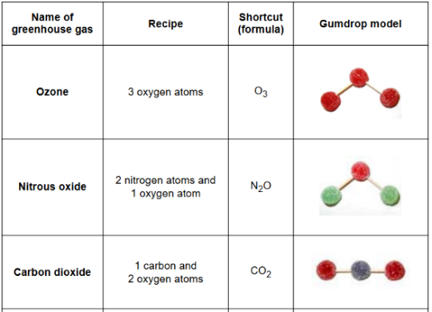  https://spaceplace.nasa.gov/gumdrops/en/  Remember to take pictures or bring them in to show the class. | Personal development  This half term the as part of our  passport activity will be cooking lunch outdoors.  At home, can you practise you  cooking skills and cook a desert?  Make sure to bring it in so we  can try it! | PSHE  Budgeting money – taking care of finances.  We will be looking at the responsibility of saving money this half term. Have a go at planning a party for 10 people – can you make a plan which includes entertainment, food and drink? Try and stick to a budget of £100…  I can’t wait to see your planned parties!
Reading  Create a book review of your favourite book you have read this year.  You can share this in Year 5’s book club. | English  Radio/News Broadcast  Imagine you are a child speaking on a BBC children’s radio programme during WWII.  Task: Create a short radio broadcast explaining:  - What life is like for children during the war  - One challenge evacuees or refugees face  - A message encouraging kindness or understanding | PE  Blindfold Obstacle course  Create an obstacle course using objects around your house e.g. chairs, cushions etc  Can you guide someone around your obstacle course? Remember to take a picture of what you made! | Maths  To support with our in class learning, please complete TTRS at home.  You could create posters of times tables to support your learning.

