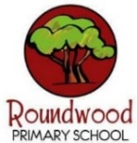
Year 4 – Summer 2
These this grid is designed to give you ideas for activities that you can complete at home with your families or independently, supporting your learning at school. Please choose one per fortnight and make sure one of these is English. We can’t wait to see your creativity! …We have increased our fluency with all times tables to 12 x 12. Remember to keep using TTRockstars regularly at home.
English  In English this half term, we will be studying the POETRY of John Lyons.  Here is an example of a ‘Blackout’ poem:  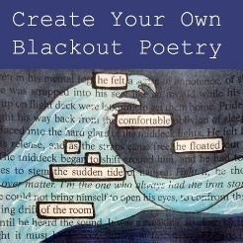  Blackout Poetry:  Take a page from an old book or magazine. Look for interesting anchor words, circle them, and use a black marker to completely black out all the other text.  The surviving words create a unique piece of visual art and poetry.  Your task is to  CREATE YOUR OWN BLACKOUT POETRY | Maths  This half-term, we will be studying SYMMETRY…  Symmetry is when an object looks the exact same on one side as the other. To see if an object is symmetrical, you draw a line of symmetry or a line dividing an object to show a perfect match on each side. It's like making a mirror image.  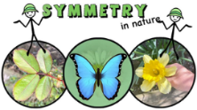  Symmetry is all around us in nature  …leaves, insects, flowers…  Your task is to FIND YOUR OWN EXAMPLES OF  SYMMETRY IN NATURE  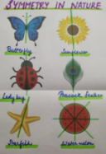  How will you present your findings? Drawings? Photographs? | Geography  This half-term, we will be studying  RIVERS  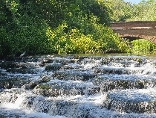  There are various rivers in our local area,  for example:  River Great Ouse, flowing east through the northern part of the county, running directly through Buckingham and Milton Keynes.  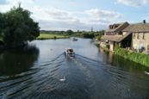  Your task is to visit a RIVER in our local area  …What did you see? What wildlife was there? How do people interact with the river?  How will you record and share your experience with your classmates? | DT  Linking to our Science Unit…  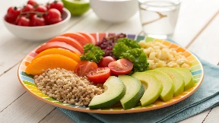  …It is very important for us all to eat HEALTHY FOOD  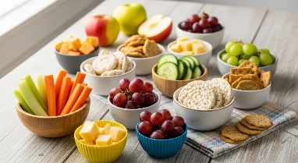  Your task is to MAKE YOUR OWN HEALTHY DISH! A meal? A snack? A side dish?  Which will you choose? How will you share your results with your classmates?  Good luck!
Science  This half term, we will be studying ‘THE DIGESTIVE SYSTEM’  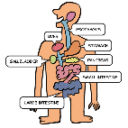  The digestive system is the body’s food processing machine. It takes the food we eat and breaks it down to give our bodies the energy and nutrients needed to grow, play, and stay healthy.  Your task is to research healthy eating  and then CREATE A POSTER  teaching others what they need to know  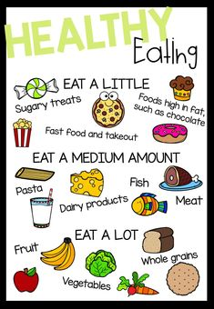 | Personal Development  This half-term, Year 4 will be ticking-off the Passport Activity:  Shape Me To meet an inspirational person  Who inspires you?  A sporting personality? A writer, musician or artist? A family member? A historical figure?    Your task is to CREATE A FACT FILE  about the inspirational person of your choice | PE  This half-term, its SPORTS DAY!  During Year 4’s PE lessons, the class will be practicing ATHLETICS in preparation for the big event…    How can you prepare for Sports Day out of school?  Your task is to keep your own  ‘PERSONAL BEST’ TRACKER  Chose an exercise  (Star jumps? Sit-ups? Squats?)  and see how many you can do in ONE MINUTE  Then… Try to improve your score over the next few weeks …Good luck! | Computing and Art  This half-term, we will be creating  ‘Looped Animations’  You can create simple animations at home by making your very own FLIPBOOK!  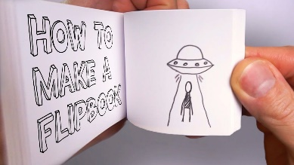  There are many tutorials on YouTube,  but here is a good place to start:  “7 Tips for Flipbook Success - Learn Basic Animation Skills”  The only limit is your imagination!  Good luck!

