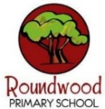
Year 4 – Summer 1
These this grid is designed to give you ideas for activities that you can complete at home with your families or independently, supporting your learning at school. Please choose one per fortnight and make sure one of these is English. We can’t wait to see your creativity! …We are increasing our fluency with all times tables to 12 x 12. Remember to keep using TTRockstars regularly at home.
English  In English this half term, we will be studying the modern classic ‘The Lion, The Witch and The Wardrobe’, by C.S. Lewis.  The story set in the fantastical world of ‘Narnia’…    Your task is to CREATE YOUR OWN FICTIONAL WORLD! Narnia is a cold, snow covered land full of magic and talking animals – What is your world like? Who lives there?  Then… MAKE A ‘TRAVEL BROCHURE’ ADVERTISING YOUR FICTIONAL WORLD!  Showcase the terrain, the wildlife, the food, inhabitants, landmarks and traditions…  The only limit is your imagination! | Art  …Continuing your ‘Travel Brochure’ English project…  DESIGN THE FLAG FOR YOUR FICTIONAL WORLD!    DESIGN THE INHABITANTS OF YOUR FICTIONAL WORLD!  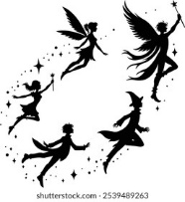  DESIGN THE LANDMARKS OF YOUR FICTIONAL WORLD!  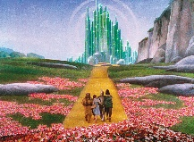 | Maths  This half-term, we will be moving into DECIMAL NUMBERS…  When using money in the real world, you need to have an understanding of decimals up to two-places.  Your task is to PLAY THE ‘UNDERSTANDING BUDGETS AND MONEY SHOPPING GAME’.  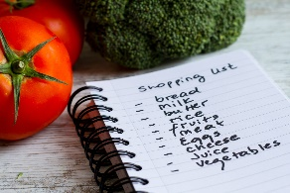  Please collect one of the ‘Understanding Budgets and Money Shopping Game’ booklets to play the game…  How will you record and share your results with your classmates? | Computing/PSHE  In PSHE we are studying  what makes YOU, YOU!  …and…  In Computing we are studying  Photo Editing  …Can you create a PHOTO PROJECT all about yourself? What are your interests? Hobbies? Family & friends? Where do you like to go?  [This can be saved digitally, or I can help you with printing out the images]  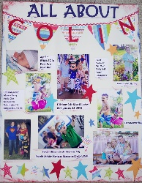
History  This half term, our History topic is ‘WORLD WAR II’  During the War, lots of children were evacuated from big cities to the English countryside.  Often, these children were only able to travel will with a small suitcase filled with their most important and treasured possessions…  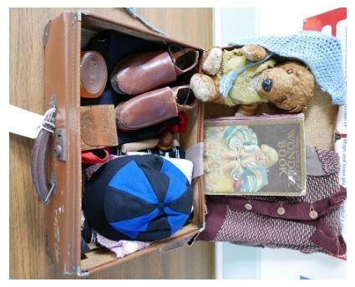  What would you take?  Your task is to FILL A SHOEBOX WITH THE ITEMS YOU WOULD TAKE TO YOUR NEW TEMPORARY HOME – a cuddly toy? Photographs? A favourite book? | DT  This half-term, our DT will be based on the rationing of English food during World War II.  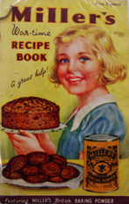  Your task is to RECREATE A WARTIME DISH.  - Spam Hash?  - Pear Crumble?  - Bubble and Squeak?  Please take home one of our ‘Wartime Recipe Booklets’ for inspiration.  How will you share your cooking with the class? | Science  This term we will be learning about ‘Habitats’.  Your challenge is…  Make a BIRD FEEDER for the birds in your garden or local area!  There are many ways to do this, for example, with loo rolls and peanut butter…  OR you could go even more elaborate!  Then, once you’ve set it up…  What happened? Who visited your feeder? Do you know which birds they were? Did you manage to record any evidence? Did you manage to get a photograph? How will you share your results with the class?  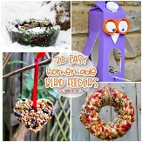 | Personal Development  One of our Personal Development activities this term is:  ‘To visit a Museum’  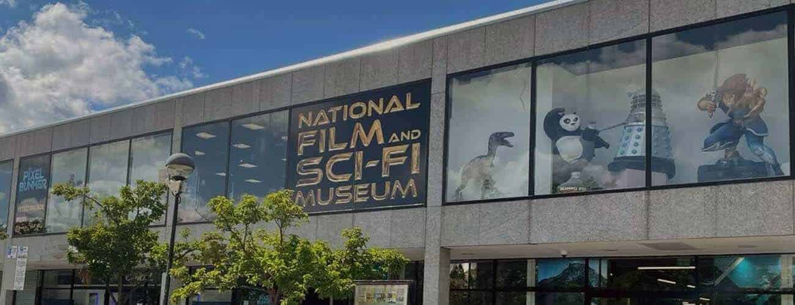  Could you visit one of the various Museums in our local area?  How will you document your adventure and share it with your classmates?

