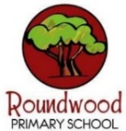
Year 4 – Spring 2
These this grid is designed to give you ideas for activities that you can complete at home with your families or independently, supporting your learning at school. Please choose one per fortnight and make sure one of these is English. We can’t wait to see your creativity! …We are increasing our fluency with all times tables to 12 x 12. Remember to keep using TTRockstars regularly at home.
Science  This half term, our Science topic is ‘ELECTRICITY’    Electricity is extremely useful,  but it can also be very dangerous!  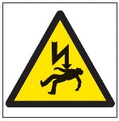  Your task is to CREATE AN ELECTRICITY QUIZ  to test & help your family and classmates.  Your questions can be based on what we learn in school  and your own research  How will you present your Quiz to the class? | English  In English this half term, we will be studying the picture books of  Oliver Jeffers  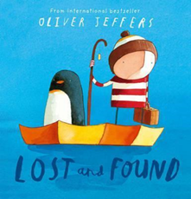  Can you write/draw your own  PICTURE BOOK?  What will be the  moral of your story?  How will you convey your moral to the reader? | Maths  This half-term, we will be moving into FRACTIONS…  A great way to learn about fractions is to cook real life PIZZA! Your task is to MAKE AND TOP A REAL PIZZA using different toppings for different fractions of the base…  For example: ½ the pizza could be vegetarian, ¼ could be pepperoni, and ¼ could be ham! Or you could try more complicated ways of slicing your pizza (into thirds? Into fifths?)…  How will your share your delicious mathematical masterpiece with the class?  [Alternatively, a drawing of your ideas would also demonstrate your understanding of fractions!] | Personal Development  Linking to our Science Unit…  This half-term, Year 4 will be ticking-off the Passport Activity:  Build Me To use an electric circuit in a product  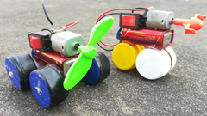  Your task is to CREATE THE ADVERTISING CAMPAIGN FOR YOUR PRODUCT!  - Posters?  - A Presentation?  - Film your own advert!?  How will you make people want to own your invention?
Geography  This half-term, we will be studying  Northern Italy  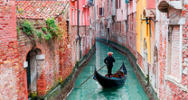  Northern Italy is home to the famous city of VENICE – where there are no roads,  only canals!  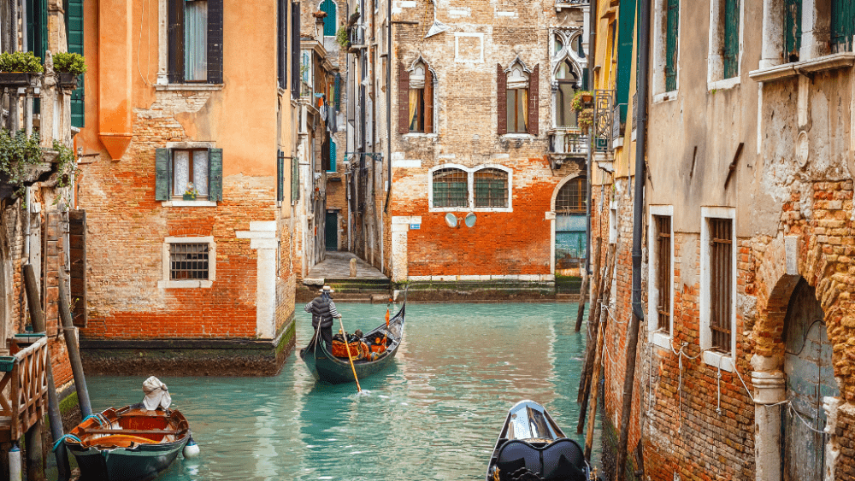  Your task is to create a research project on VENICE  …its cuisine, landmarks, unique history…  How will you record and share your research with your classmates? | DT  Linking to our Geography Unit…  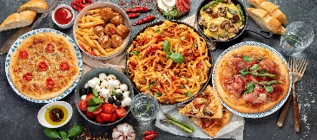  Italy is very famous for its delicious food!  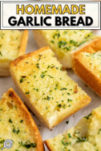  Your task is to MAKE YOUR OWN GARLIC BREAD! There are many different simple recipes to create your own garlic bread at home – which will you chose? How will you share your results with your classmates?  Good luck! | Drama / Music  We are all very excited to be bringing you the Year 3 & Year 4 Spring Performance!  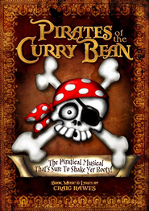  Scripts have already been sent home… Please spend time practising your lines and learning your scenes.  Remember: you need to know who speaks before you and what they say so that you are ready for your part. Also make sure you know what acting you should be doing and when you are on and off the stage…  …Good luck!

