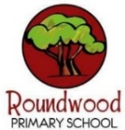
Year 4 – Spring 1
These this grid is designed to give you ideas for activities that you can complete at home with your families or independently, supporting your learning at school. Please choose one per fortnight and make sure one of these is English. We can’t wait to see your creativity! …We are increasing our fluency with all times tables to 12 x 12. Remember to keep using TTRockstars regularly at home.
Science  This half term in Science, we will be learning about ‘Sound’.  Your task is to CREATE YOUR OWN HOMEMADE MUSICAL INSTRUMENT!  You could make a stringed instrument with a shoebox and elastic bands? You could make a percussion instrument with a tin-can and a balloon? [There are lots of ideas on the internet]  Then… Your task is to CREATE SOME MUSIC WITH YOUR HOMEMADE INSTRUMENT! You could join-up with other Year 4 students and create your own ‘homemade instrument class band!’ | English  In English this half term, we will be studying the ancient text ‘Beowulf’, as retold by Michael Morpurgo.  The story is an action-packed legend, dating back 1000 years!  Later in the term, we will be writing our own legends… Who will your hero be?  Your homework task is to DESIGN A HERO who will be the main character of your legend. What do they look like? What are their strengths or weaknesses? What is their quest?  How will you present your character to the class? | Maths  Using our current topic of Multiplication and Division…  Create your own  TIMES TABLES FLASHCARDS  to help remember all tables up to 12 x 12  - Will they contain helpful for hints for remembering that multiplication fact?  - Will they contain the division facts?  …Or the whole fact family?  - How will you use them? Can your cards be made into a game?  Bring in your cards to help test your classmates on their times tables! | Art  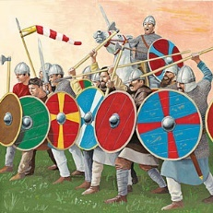  Anglo-Saxon shields were made from a circular piece of wood constructed from planks which had been glued together…  Make your own ANGLO-SAXON SHIELD! You could use cardboard, a paper plate, or even wood! Bring in your design and defend your classmates!  [Google ‘Anglo Saxon shields’ for pattern ideas]
History/Geography  This half term we will be learning about the ‘Anglo Saxons and Vikings’ in our History lessons.  The Vikings originated from Scandinavia, now known as: Denmark, Norway and Sweden.  Choose one of these three European nations and CREATE A FACT FILE about what the country is like in the modern age.  Use the internet or books to research your project. What is their culture? Their cuisine? Their flag? What are they famous for? What are their landmarks?  How will you present your finished project?  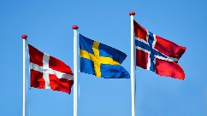 | Music  Our Music topic for this half term is ‘Compose with Your Friends’. You will be writing and performing your very own songs, with music and singing…  What will your songs be about?  Your task is to WRITE SOME LYRICS for the songs which we will later be writing the music for in class!  You could take inspiration from any of our current topics, or something completely different – the possibilities are endless!  Write your words and bring them in to share with your class band!  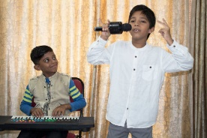 | DT: Anglo Saxon Honey Shortbread  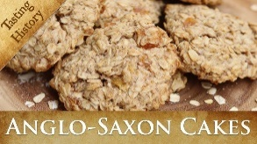  During the Early Middle Ages, sugar hadn't been discovered yet, so the Anglo-Saxons used dried fruits and honey to sweeten their puddings…  Cook your very own ANGLO-SAXON HONEY SHORTBREAD! How will your record the process? Will you bring in your cakes to share with the class?  There are many online versions of the recipe, including here:  https://guides.brit.co/guides/bake-anglo-saxon-honey-shortbread  Goodluck! | Personal Development  As we begin 2026, let’s take some time to look back at 2025. What are you proud of? What did you achieve? Perhaps you have been:  - Doing more jobs to help out at home?  - Finding new ways of making your friends smile?  - Taking up a new hobby?  What are your resolutions for next year? Are there ways you can safely help others in the year ahead?  How will you record your reflections on the past and plans for the future?  

