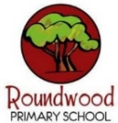
Year 4 – Autumn 1
These activities are designed to give you ideas of activities that you can complete at home with your families or independently, to support your learning at school. Please choose one per fortnight and make sure one of these includes English. We can’t wait to see your creativity!
Science  This term we are learning how to  ‘Group and Classify Living Things’.  Your challenge is…  Make a BUG HOTEL for the invertebrates in your garden or local area!  There are many ways to do this, for example, with cut plastic bottles and twigs… OR you could go even more elaborate!  Then, once you’ve set it up…  What happened? Who visited your hotel? Do you know which invertebrates they were? Did you manage to record any evidence? Did you manage to get a photograph? How will you share your results with the class? | English  In English this half term, we will be studying the modern classic ‘The Borrowers’, by Mary Norton.  The story is a lovely tale about friendship and fantastical tiny people!  Later in the term, we will be writing Newspaper Reports based on the incredible events in the book…  Your homework task is to WRITE A NEWSPAPER REPORT about a real event from your life or a topic you are passionate about… Maybe a football match you played in? Maybe a daytrip you went on? Maybe a report about the invertebrates in your local area? | Maths  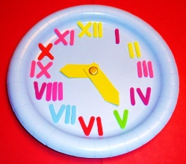  The most common Roman numerals we see in modern times occur on a clock or a watch.  Can you draw, design or build your very own clock using ROMAN NUMERALS on its face?  Then… practice your time-reading skills and recognition of Roman numerals using the clock you have created! | Art  In Art, we are studying Roman Mosaics. The examples we are creating at school all use small pieces of coloured paper. However…  Can you create your own MOSAIC using something other than paper? Stones? Sequins? Beads? Pasta!?  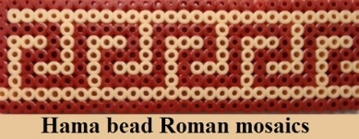  What will your design be?
DT  After the Romans invaded Britain, they brought many new foods with them… Amongst these were fruits such as grapes, apples, cherries and plums…  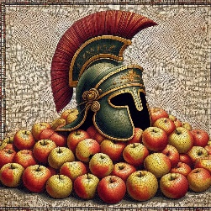  Your challenge is to create your very own ROMAN FRUIT SALAD!  You could take photographs to share with your classmates, or even bring a sample into school! | History  Bancroft Roman Villa is a Roman villa in the Bancroft district of Milton Keynes in Buckinghamshire, England. Originally a winged-corridor house, the villa eventually became a grand building with mosaics and a formal garden.  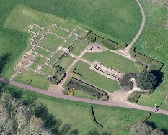  Why not visit Bancroft Roman Villa with your family? Could you take some pictures to share with your classmates? | PE  In PE, Year 4 are learning to play Netball. Essential skills for this sport include throwing and catching…    Can you invent your own THROWING AND CATCHING GAME? Could you teach it to your friends at school? What equipment do you need? How will you present the rules? | Computing  In Computing, Year 4 are learning all about how to stay safe on-line…    Can you design your own E-SAFETY POSTER?  We could even put them up around the school to help our fellow classmates…

