
Art / DT
Courage | Respect | Curiosity
Painting & mixed media: portraits
Investigating self-portraits by a range of artists, pupils use photographs of themselves as a starting point for developing their own unique self-portraits in mixed media.
History / Geography
Resilience | Courage | Respect

South America - why does the amazon matter?
- Tropical and temperate rainforests
- Location of the Amazon Rainforest
- Features of the Amazon rainforest
- Food from tropical rainforests
- Brazil nut production
- People of the Amazon Rainforest
- Protecting the rainforest
Science
Curiosity | Resilience |  | Happiness
Animals Including Humans

- How does a baby grow into a toddler?
- How do children become adults?
- Why do animals have different gestation periods?
- What is life expectancy?

Maths
Happiness | Resilience | Responsibility
Shape
- Understand and use degrees
- Classify angles
- Measure and estimate angles
- Calculate angles
- 3-D shapes

English
Respect | Curiosity | Courage
Into the Jungle
- Create a campaign
- Biography
- Setting descriptions
Year 5 – Summer 2
PE/Games
Happiness | Courage | Responsibility
Rounders
- Develop an understanding of the rules
- Throwing Skills
- Catching Skills
- Batting Skills
- Working as a Team

PSHE
Happiness | Resilience | Courage

Growing and Changing
- How are they feeling?
- Taking notice of our feelings
- Changing bodies and feelings
- Growing up and changing bodies
- Help! I’m a teenager – get me out of here!
- Dear Ash
- Stop, start, stereotypes

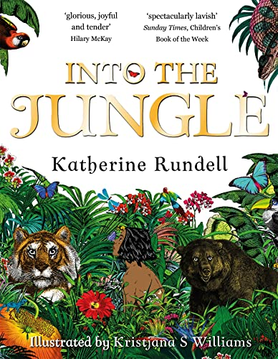
Visits/Experiences
Courage | Happiness | Curiosity

Transition Day
Sports Day

Computing
Responsibility | Curiosity | Happiness
Programming B

- Exploring conditions
- Selecting outcomes
- Asking questions
- Designing a quiz
- Testing a quiz
- Evaluating a quiz
Music
Courage | Happiness | Responsibility
Charanga Unit:
- Explore its musical style through the style indicators of this music and its performers
- Embed a deeper understanding of the musical concepts related to the song
- To play and perform an instrumental part
RE
Respect | Responsibility | Curiosity
Why are some places in the world significant to believers?

- What can make a place significant?
- How can religious events make a place significant
- What makes the Harmandir Sahib significant to many Sikhs?
- How can a river be a goddess?
- Can relics make a place significant?
- Who can visit significant places?

