
Science
Curiosity | Resilience | Happiness
Life cycles
- Step 1 Life cycles of mammals
- Step 2 Life cycles of amphibians (frogs)
- Step 3 Life cycles of insects
- Step 4 Life cycles of birds
Animals including humans
- Step 1 The human life cycle
- Step 2 Babies and children
- Step 3 Adolescence and puberty
- Step 4 Adults and the elderly
- Step 5 Gestation periods of mammals
- Step 6 Gestation periods and lifespan

English
Respect | Curiosity | Courage
Beetle Boy
- To persuade – Speech ‘Save the beetles’, letter to Lucretia Cutter
- To inform- Biography The life and work of Dr Cuttle
- To entertain –setting description of the Beetle Room, Comic strip of Beetles on a mission
- To discuss- Should humans use animals for Science? Are insects more important than we think?

Maths
Happiness | Resilience | Responsibility
Decimals and percentages
- Decimals up to 2 decimal places
- Equivalent fractions, decimals and percentages
- Thousandths as fractions and decimals
- Thousandths on a place value chart
- Order and compare any decimals with up to 3 decimal places
- Round to the nearest whole number
- Understand percentages
- Percentages as fractions
- Percentages as decimals
History / Geography
Resilience | Courage | Respect
Shang Dynasty

- Where and when was the Shang Dynasty?
- What were their ideas, beliefs and attitudes?
- What were ‘Dragon’s Bones’?
- What does this item tell us about life during the Shang Dynasty?
- What impact does limited evidence have to our knowledge and understanding?
Year 5 – Summer 1

Art / DT
Courage | Respect | Curiosity

- Explain that fruits and vegetables grow in different countries based on their climates and identify which grow where.
- Identify which foods grow in which season and find recipes that contain seasonal foods.
- Know that importing food impacts the environment.
- Identify the equipment used to prepare food and explain why food needs to be prepared safely.

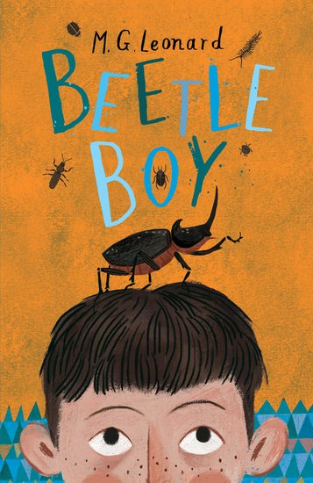
PSHE
Happiness | Resilience | Courage
Being my Best
- It all adds up!
- Different skills
- My school community (2)
- Independence and responsibility
- Star qualities?
- Basic first aid, including Sepsis Awareness

PE/Games
Happiness | Courage | Responsibility
Cricket

- Bat with control and accuracy
- Bowling techniques
- Catching skills
- What are the differences between open and closed shot?

Visits/Experiences
Courage | Happiness | Curiosity

Camp overnight
Solar farm visit
Science fair
Computing
Responsibility | Curiosity | Happiness
Creating media - Introduction to vector graphics
- The drawing tools
- Creating images
- Making effective drawings
- Layers and objects
- Manipulating objects
- Becoming a graphic designer

Music
Courage | Happiness | Responsibility

Enjoying musical styles
- Improvising
- Understanding music
- Perform and share
RE
Respect | Responsibility | Curiosity
Who should get to be in charge?
- Explain how religious laws are created, using examples from Islam.
- Contrast religious law creation with British law creation.
- Discuss and write ideas on the succession of religious leadership.
- Linking Muhammad’s practices, sayings or actions to the formation of some religious laws.
- Understanding how Guru Nanak chose his successor and how this method compares to other religious or cultural practices.

