
Maths
Place Value within 100
- Counting in 10s and partitioning into 10s and 1s.
- Number lines to 100, recognising 1 more and 1 less and Comparing numbers within 100

Time (1 weeks)
- hours, minutes and seconds.
- Tell the time to the hour and half hour

Money (1 week)
- Unitizing, recognising coins and notes
- Counting coins

Position and Direction (1 week)
- Describe turns, forwards/backwards
- Left/right, above/below
- Ordinal numbers

Art / DT
Curiosity | Resilience | Happiness
Colour Splash
- Making colours
- Painting with colour
- Printing with paint
- Exploring colour mixing
- Clarice Cliff plates

History / Geography
Local area: Planning and Mapping routes
- Locating places in the school grounds
- Mapping the school grounds
- Planning a route within the village
- Observing features along planned route
- Mapping the route we took
- Improving our school grounds
English
The Queen’s Hat and Katie in London
- To write simple sentences
- To use adjectives to describe objects, characters and settings
- To write question sentences
- To write simple recount texts
- To write an information text about London landmarks

Science
Seasonal Changes – Spring and Summer
- Changes in Summer
- Collect and record data
Plants
- Deciduous Trees
- Evergreen Trees
- Trees in my local area

Caring for the Planet
- Why is it important to care for our planet?
- How can we care for our planet?

PE/Games
Courage | Resilience | Respect

Athletics
Striking and Fielding

PSHE
Respect | Responsibillity | Courage
Growing and Changing
- Healthy me
- Then and now
- Taking care of a baby
- Who can help
- Surprises and secrets
- Keeping privates private

Year One – Summer 2

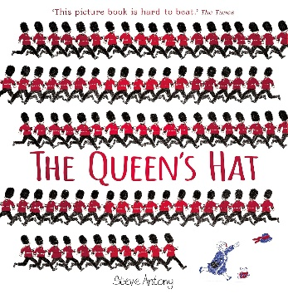
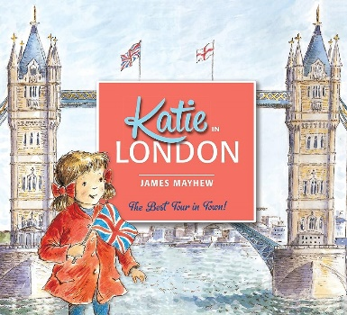

RE
Respect | Curiosity
Why should we care for others?
- Why do people care for others?
- How might Muslim people show it is important to care for others?
- Is giving always the same?
- What can we learn about caring for others from stories?
- Why might some Humanists choose to care for others?
- What inspires some people to care for others?
Visits/Experiences

Sports Day (Tuesday 30th June)
Transition day in new classes (Tuesday 7th July and Wednesday 15th July)
Trip to Cotswold wildlife park (Wednesday 8th July)

Computing
Creating Media – Digital Writing

- Exploring the keyboard
- Adding and removing text
- Exploring the toolbar
- Making changes to text
- Explaining my choices
- Pencil or Keyboard
Music
Happiness | Respect | Curiosity
Explore sounds and make a story
How does music teach us about looking after our planet?

- Listen and appraising different songs
- Finding the pulse
- Learning to sing songs
- Playing along with songs with or without notation
- Improvising with instruments and voices
- Composing and creating compositions
- Perform and share with others
Languages

