
Art / DT
Curiosity | Resilience | Happiness
Cooking and nutrition: Smoothies
- Identifying fruits
- Describing where fruits and vegetables grow.
- To practice cutting and juicing skills
- Tasting ingredients and selecting combinations for a recipe
- Making a smoothie following a recipe
- Evaluate the smoothie against a design brief.
History / Geography
When three queens ruled
- Which three queens of England are most remembered in history and why?
- How different was life in England when the three queens were ruling?
- How do we know about the queens who lived so long ago?
- What important changes happened when each of the queens ruled?
- How should we remember these famous queens?
English
Novel Focus: Jack and the Jelly Beanstalk
- To write simple sentences
- To use adjectives to describe objects, characters and settings
- To use suffixes –er and –est to compare
- To write instructions using simple command sentences and words to sequence

Maths
Place Value to 50 (1.5 weeks)
- Partitioning into 10s and 1s
- Number lines to 50, estimating position on a number line to 50
- Comparing numbers - 1 more, 1 less
Length and Height (1 week)
- Compare lengths and heights
- Measuring with objects then with cm
Mass and Volume (1.5 weeks)
- Heavier and lighter
- Comparing and measuring mass
- Full/empty. Compare and measure volume and capacity.

Science
Seasonal Changes – Spring
- The weather in Spring, signs of spring
Plants
- Plant parts
- Tree parts
- Wild and garden plants
- Plants in my local area
- Deciduous trees
- Evergreen trees
- Trees in my local area
Planting seeds
- Observation of different types and changes over time

PE/Games

Striking and fielding games

Team building
PSHE
Being my Best
- I can eat a rainbow
- Eat well
- Harold’s wash and brush up
- Catch it! Bin it! Kill it!
- Harold learns to ride his bike
- Pass on the praise!

Year One – Summer 1

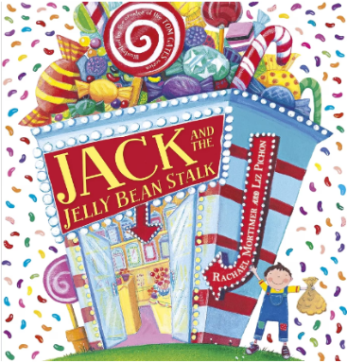

RE
How do we know that new babies are special?
- How do we know that babies are special?
- What do some Muslim people do to show a new baby is special?
- What is Aqiqah and why is it important to some Muslims?
- What is Jatakarma and why is it important to some Hindu people?
- What promises might people make for a new baby?
- How are some babies named?
Music
Having fun with improvisation

Understanding music
- Finding and keeping a beat
- Playing/clapping simple rhythmic patterns with long and short sounds
- Respond to high and low pitches
Improvising
- Keeping a beat when improvising
- Clapping 3 beat rhythms with long and short sounds
- Improvising with different notes
Listen and respond
- Listen and copy actions
- Responding to questions about the music
Visits/Experiences

Forest School
Group 1 – Wednesday 15th, 22nd, 29th April
Group 2 – Thursday 7th, 14th, 21st May
Farm visits
Group 1 - 14th April
Group 2 - 21st April
Sing and share afternoon – 22nd May

Personal Development Passports

- To login and out of Numbots
- To know how to identify my needs
- To create a piece of art/sculpture using natural materials
- To read and discuss ‘Pink is for Boys’
Computing
Data and Information – Grouping Data

- Label and match
- Group and count
- Describe an object
- Making different groups
- Comparing groups
- Answering questions

