
History / Geography
Continents and Oceans
- Earth View – globes, satellite images
- Mapping the world – continents
- The world’s five oceans
- Rivers of the world
- Mountains and landmarks of the world
- The UK’s place in the world
Maths
Addition and subtraction to 20 (3 weeks)
- Add by counting on within 20
- Add ones using number bonds
- Find and make number bonds to 20
- Doubles and near doubles
- Subtracting by counting back and finding the difference
- Related facts and missing number problems
Place Value within 50 (3 weeks)
- Counting from 20 to 50
- Counting by making groups of 10
- Making groups of tens and ones and partitioning
- Labelling and estimating Number lines to 50
- Finding 1 more and 1 less

Art / DT
Sculpture and 3D - Paper Play
- Tube towers – rolling to make 3D structures
- 3D drawings – shape paper to make 3D drawings
- Tree of life – applying paper shaping skills to create sculpture
- Plan, create and paint a giant spider 3D sculpture in the style of artist Louise Bourgeois
English
Lost and Found by Oliver Jeffers
- Sequence and retell the story
- Character and setting descriptions
- Simple non-chronological report with facts about penguins
- Letter from the penguin to the boy

Science
Animals - complete
- Compare and group
- Carnivores
- Herbivores
- Omnivores
Sustainability – caring for the planet
- Why is it important to care for the planet?
- How can we care for our planet?
Seasonal Changes
- Changes in Spring
Plants
- Spring

PE/Games
Dance

Net/Wall games
PSHE
Rights and Responsibility
- Harold has a bad day
- Around and about the school
- Taking care of someone
- Harold’s Money
- How should we look after our money?
- Basic First Aid

Year One – Spring 2

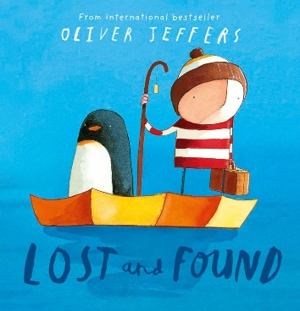

RE
Why should we care for the world?
- Who owns the world?
- Who can care for the world?
- Why do some people believe we should care for the world?
- What do some Muslim people believe about caring for the world?
- What other reasons are there for caring for the world?
- Why should we care for the world?

Visits/Experiences
World Book Day – March 5th
Waddesdon Manor trip – March 17th

Computing
Programming A – Moving a robot

- Buttons
- Directions
- Forwards and Backwards
- Four directions
- Getting there
- Routes
Music
Introducing Tempo and Dynamics
How does music make the world a better place?
- Listen and appraising different songs
- Finding the pulse
- Learning to sing songs
- Playing along with songs with or without notation
- Improvising with instruments and voices
- Composing and creating compositions
- Perform and share with others
Languages

