
Art / DT
Puppets
- Joining fabrics
- Designing my puppet
- Making and joining my puppet
- Decorating my puppet
History / Geography
The Great Fire
- How can we work out why the Great Fire started?
- What happened during the Great Fire and how do we know?
- Why did the fire burn down so many houses?
- Could more have been done to slow the spread of the fire?
- How did people manage to live through the Great Fire?
- How shall we rebuild London after The Great Fire?
Maths
Shape (1 week)
- Recognise, name and sort 3D shape
- Recognise, name and sort 2D shapes
- Patterns with 2D and 3D shapes
Place Value within 20 (3 weeks)
- Count and understand make up of numbers 11-20
- One more and one less
- Using and estimating numbers to 20 on a number line
Addition and subtraction to 20 (2 weeks)
- Add by counting on within 20
- Add ones using number bonds
- Find and make number bonds to 20

English
Vlad and the Great Fire of London
- Sequencing events
- Describe a setting and characters
- Recount of the Great Fire of London

Poetry – The Sound Collector by Roger McGough
- Write in the style of the poem
- To describe the sound collector

Science
Seasonal Changes
- Changes in Winter
Plant
- Winter
Animals
- Mammals
- Birds
- Fish
- Amphibians
- Reptiles
- Compare and group
- Carnivores
- Herbivores
- Omnivores

PE/Games

- Gymnastics

- Sending and Receiving
PSHE
Keeping Myself Safe
- Super sleep
- Who can help?
- Good or bad touches
- Sharing pictures
- What could Harold do?
- Harold loses Geoffrey

Year One – Spring 1

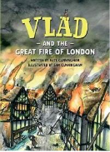
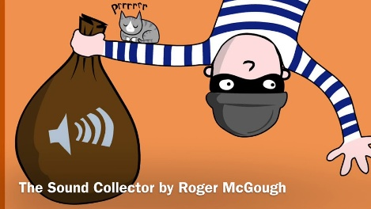

RE
What is God’s job?
- How do the 99 names of God tell us about what some Muslims believe God does?
- Why have some people decided to trust God?
- What does the Tenak say about God?
- What do some people believe God might do as a person?
- What do some Hindu people believe about God?
- What do some Zoroastrian people believe about God?

Visits/Experiences

Visit to the library in Buckingham Tuesday 3rd February

Computing
Creating Media – Digital Painting
- How can we paint using computers?
- Using shapes and lines.
- Making careful choices.
- Why did I choose that?
- Painting all by myself.
- Comparing computer art and painting.

Music
Exploring Sounds
- Musicianship – understanding music
~maintaining a steady beat
~joining in with rhythm and
melodic patterns
- Listening and responding to music
- Learning to sing songs
- Playing along with songs with or without notation
- Improvising with instruments and voices
- Composing and creating compositions
- Perform and share with others
Languages

