
Science
respect | curiosity | Responsibility
Seasonal Changes
- Changes in autumn?

Materials
- Explore materials – wood, plastic, glass and metal
- Explore materials - rock
- Objects and materials
- Melt and freeze
- Float or sink
- Does it absorb water?

Seasonal Changes
- Changes in Winter

English
Resilience | curiosity
The Leaf thief – Alice Hemming
- Sequencing the story
- Character and setting descriptions

The Three Little Pigs – Traditional Tale
- Sequencing the story
- Character and setting descriptions – use of adjectives
- Wanted Poster
- Writing questions to the wolf about his behaviour

Maths
resilience | courage | curiosity
Addition Subtraction within 10 (5 weeks)
- Write number sentences
- Addition fact families
- Number bonds within 10 and of 10
- Adding together
- Addition problems
- Finding a part – subtraction
- Taking away, crossing out - how many left?
- Subtract using number line
Shape (1 week)
- Recognise, name and sort 3D shape
- Recognise, name and sort 2D shapes
- Patterns with 2D and 3D shapes

Art / DT
curiosity | happiness | resilience
Drawing: Exploring line and shape
- Exploring line
- Musical lines
- Exploring shapes
- Shape in art
- Klee portraits

History / Geography
respect | responsibility | curiosity
Local Area – Where do we live?
- Our homes
- Our local area
- The street outside our school
- Buildings and features near our school
- A survey of how we get to school
- Mapping our journey to school

PE/Games
happiness | resilience | responsibility

Ball skills unit 1

Fitness
PSHE
respect | honesty | responsibility
Valuing difference
- Same or different
- Unkind, tease or bully?
- Harold’s school rules
- It’s not fair
- Who are our special people?
- Our special people balloons

Circle Time games and activities

Year One – Autumn 2
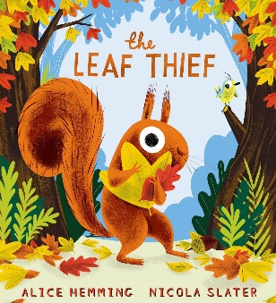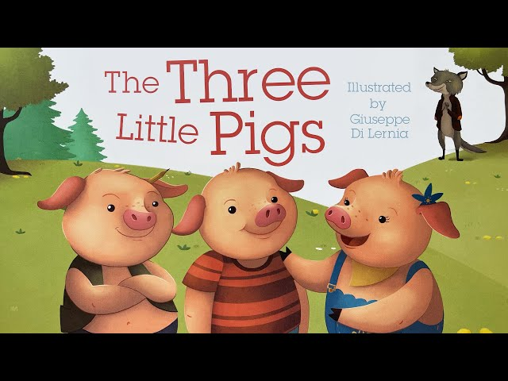

RE
curiosity | respect
Should we celebrate harvest or Christmas?
- Harvest as a festival of thanksgiving.
- To show concern for the wider world where there is not enough food.
- Giving thanks is a shared human experience.
- Stories of Cain and Abel, Noah and Exodus
- Key features of Sukkot (Jewish festival) and Christmas (Christian festival)

Personal Development Passports activities
confidence | resilience | responsibility
Future Me
- To know my address

Inspire Me
- To build a den
- To know a selection of nursery rhymes

Shape Me
- To read and discuss the book ‘Pink is for Boys’

Visits/Experiences
Happiness | Curiosity  Courage | Responsibility  Respect

Local area walks for geography fieldwork.
Forest School – two groups in blocks of 3 weeks
KS1 Christmas performance

Computing
curiosity | resilience
Creating media: Digital painting
- How can we paint using computers?
- Using shapes and lines
- Making careful choices
- Why did I choose that?
- Painting all by myself
- Comparing computer art and painting
Music
happiness | curiosity | respect
Dance Sing and Play
How Does Music Tell Stories About the Past?

