
Art / DT
Structures: Constructing Windmills
- Making a stable structure
- Making the sails using tools and equipment accurately
- Use joins to attach the sails
- To evaluate the structure
History / Geography
Toys
- What are our toys like today?
- What are other people’s toys like?
- How can we tell these toys are old?
- What were our grandparent’s toys like?
- Who played with these toys a long time ago?
- How can we set up a toy museum?
Maths
Place Value within 10 (5 weeks)
- Sorting and counting objects
- Count on and backwards
- 1 more, 1 less
- Compare groups then numbers using fewer, more, same, less than, greater than, equal to
- Order objects and numbers

Addition Subtraction within 10 (2 weeks)
- Introduce parts and wholes, using part whole diagram
- Write number sentences
- Addition fact families

English
Mr Gumpy’s Motor Car
Journey
- Labels and captions
- Lists
- Speech bubbles
- Thank you letter
- Story maps
- Sequencing
- Using capital letters

Science
The Human Body
- Identify and name parts of the body
- Draw and label body parts
- Sight
- Sound
- Taste
- Touch
- Smell

PE/Games

PE fundamentals

Invasion Games
PSHE
Me and my relationships
- Rules to keep us safe, rules for classroom
- Feeling (recognising clues in body language, types of feelings, how manifest themselves, ‘not so good’ feelings, how feelings can be hurt
- Belonging to groups and communities
- Qualities in friends, making up strategies
- Simple conflict resolution strategies
- Giving and receiving positive feedback and how it makes us feel.

Circle time games
Year One – Autumn 1
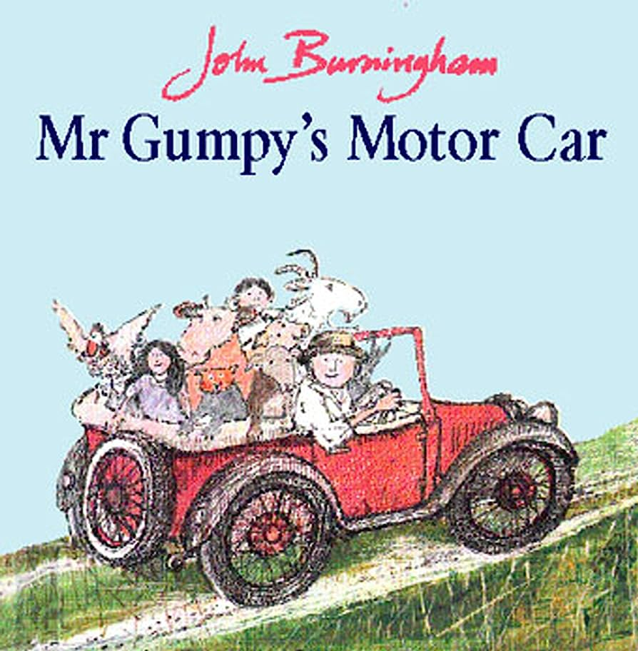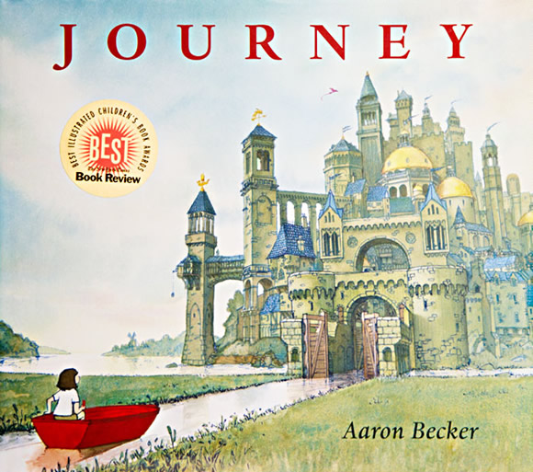

RE
Is everybody Special?
- Parables as stories with meaning – The lost Coin and The Lost Sheep
- Look at baptism and what takes place during ceremony
- Establish that these are both Christian
- How they belong in their community

Visits/Experiences

17th October – Virtual Reality event
24th October - Harvest Festival

Computing
Online Safety
- Login safely and importance of keeping passwords safe
- Accessing their work area and retrieving files
- Familiarisation of resources
- Exploring tools – save, print, open etc.
Music
Introducing Beat
How can we make friends when we sing together?

Languages

