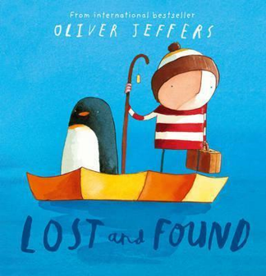
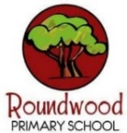
Science
Electricity
- Which appliances use electricity?
- How can I be safe when exploring electricity?
- Can I identify the parts of a simple circuit?
- Will my bulb light without a switch?
- Are all metals good conductors?

Design and Technology
Mechanical Cars
- Describe key design improvements in the history of the automobile.
- Measure and compare the distance travelled by different mechanical cars.
- Choose and use appropriate tools and materials to make mechanical cars.
- Draw exploded diagrams and annotated sketches of my different mechanical cars.
- Assess the product against the design criteria.

Geography
Europe: what is it like to live in northern Italy?
- Locate northern Italy on a map and describe how far it is from where we live.
- Use maps to identify key physical and human geographical features of Northern Italy.
- Use multiple sources of information to investigate what a town in northern Italy is like.
- Compare northern Italy to the region of the UK where we live.

Maths
- Multiplication and division
- Multiply and divide 3 digits by 1 digit
- Length and perimeter
- Equivalent lengths (kilometres and metres)
- Calculate the perimeter of rectilinear shapes
- Fractions
- Understand improper fractions and mixed numbers

Mastering Number Year 4 – Going for Gold
- Making connections to learn all times table facts to 12 x 12
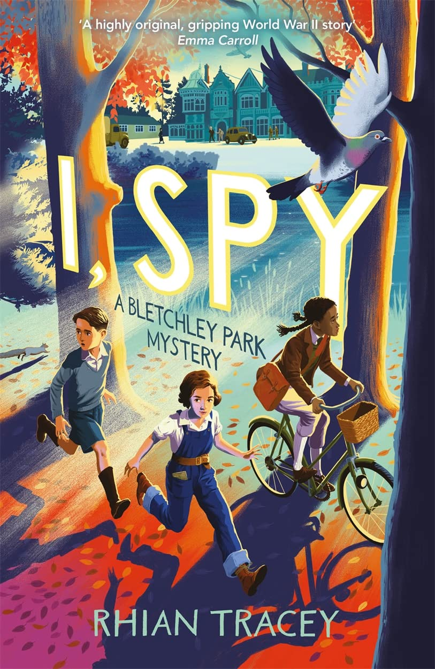
English
Oliver Jeffers – A study of:
Lost and Found
The Incredible Book Eating Boy
How to Catch a Star
The Day the Crayons Quit
Stuck
The Heart and the Bottle
To persuade – letter from a crayon
To inform- diary recount
To entertain –story, diary, poem and description
To discuss- Comparison of all the books

Class Novel: ‘I, Spy’ by Rhian Tracey

RE
Who was Jesus really?
- Share ideas about what Jesus might have been like.
- Think critically about different representations of Jesus.
- Explain the actions and qualities of Jesus which led some people to believe he was the Messiah.
- Interpret extracts from prophecies in the Old Testament and making connections with events in the New Testament.
- Identify messages in Jesus’ parables.

Music
Feelings Through Music
How does music teach us about our community?

Learning, singing and performing songs for our Spring Performance!

PE/Games
Outdoor Adventurous Activities
Football/Swimming
Computing

Programming – Repetition in shapes
Use loops in code to draw shapes and repeated patterns.
Programming a screen turtle
Programming letters
Patterns and repeats
Using loops to create shapes
Breaking things down
Creating a program

Visits/Experiences
Year 3 and 4 Spring Performance

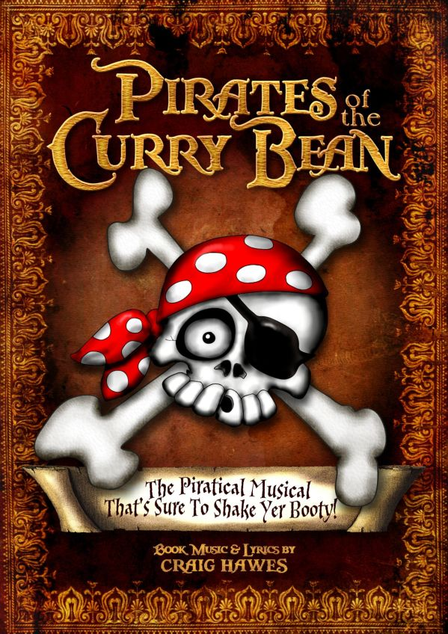

Performance Dates / Times TBC

The picture books of…
Oliver Jeffers

PSHE

Rights and Respect
- Who helps us stay healthy and safe?
- It’s your right
- How do we make a difference?
- In the news!
- Safety in numbers

Year Four – Spring 2

