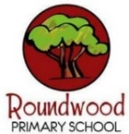
Maths
- Number: Addition and subtraction
- Measurement: Area
- Number: Multiplication and division A

Times tables
Focus times tables for this half term:
8x and 6x table
English

Novel Focus: ‘How to Train Your Dragon’
by Cressida Cowell

The first book in the series about ‘Hiccup’, the young son of a Viking Chief!

- Diary Entries
- Persuasive Letter
- Descriptive Writing

Science
States of Matter
- Comparing and group materials – Can I sort materials according to their particles?
- Properties of gases – How heavy are different gases?
- Heating and cooling – How does heat cause solids to change?
- Evaporation and condensation “The Water Cycle” – How does water change its state?
- Working Scientifically: Fair Test practical – How can I change my solid into a liquid? How can I change water into a gas and then back into a liquid again?

Geography
The UK: Who are we?

Regions and counties of the UK

I can name and locate some of the UK’s regions and counties.

Images of the UK

I can use enquiry to understand how images can be used to describe people and places.

The UK: Moving in, moving out

I can describe what is meant by migration and begin to explain why different people have settled in the UK.

Impacts of the UK's changing population

I can begin to explain some of the changes in the UK's population, including its age, location and the impact of migration.

Moving within the UK

I can explain why people move within the UK and understand how we can plot movement on a map.

Revealing the UK's global links

I can describe the UK's global links, and explain how these contribute to the character of my local area.

Visits/Experiences

Christmas Carol Service
Christmas Lantern Procession
PSHE

Valuing Difference
- Can you sort it?
- What would I do?
- The people we share our world with
- That is such a stereotype!
- Friend or acquaintance?
- Islands

Music
Exploring Feelings When You Play
Social Question: How Does Music Connect Us with Our Past?

Novel Focus:
‘The Wolves in the Walls’ by Neil Gaiman
Year Four – Autumn 2

RE and Worldviews
What makes some texts sacred?
- Drawing out connections between beliefs and practices.
- Comparing and making links between scriptures from different worldviews.
- Identifying the role and value of scripture in some people’s lives.
Art / DT
Structure: Pavilions
- Produce a range of free-standing frame structures of different shapes and sizes.
- Design a pavilion that is strong, stable and aesthetically pleasing.
- Select appropriate materials and construction techniques to create a stable, free-standing frame structure.
- Select appropriate materials and techniques to add cladding to their pavilion.

Novel Focus:
‘How to Train Your Dragon’
By Cressida Cowell
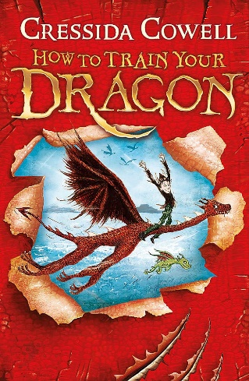
PE/Games
CT – Swimming at Swan Pool
S4A – Dance
Computing
Audio production
Creating Media A Audio production – Record, edit, and combine sounds to produce audio (e.g., podcasts).

- Learners will use Audacity to produce a podcast, which will include editing their work, adding multiple tracks, and opening and saving the audio files.
Languages

The People Around Me

- Meet my family
- Have you got any pets?
- The alphabet
- What’s their name?
How do you spell…?

