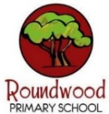
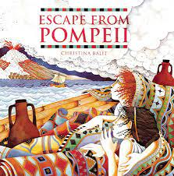
History
Romans
Enquiry Question: What impact and influence did the Roman Empire have on life in Britain?
- Overview of previously studied units and map on timeline. Place Roman Empire on timeline.
- Beliefs and importance of Gods / Goddesses.
- Building of roads and Roman baths.
- Boudicca rebellion and Celtic uprising.
- Influence that Romans had in Britain – language, numbers, engineering, architecture, art, laws, aqueducts and sanitation.
PE/Games
Swimming at Swan Pool
Netball
Visits/Experiences

- Harvest Festival – date TBC
Computing - CC
Online Safety
- Recap of knowledge
- Email simulation
- Digital Footprint
- Waremal email
- Online Safety tips
Music
Musical Structures
Musical sections that repeat or change help create the structure, or form, of a piece of music or a song. Look for patterns in the sections of music and songs within this unit. Verses and choruses can repeat or alternate and these provide structure in music.
RE
How can we talk about religions and worldviews respectfully?
How can we talk about religions and worldviews respectfully?
Exploring the origins and connections of various Religions

PSHE
Happiness | Resilience | Honesty
Me and My relationships
- Human machines
- Ok or not ok?
- An email from Harold!
- Different feelings
- Under pressure
Art / DT
Roman Mosaics
- Drawing and designing a mosaic inspired by Roman artefacts.
- Collage / Mosaic – make a mosaic around a central motif.
Roman Aqueducts
- Design an aqueduct.
- Sculpt and paint an aqueduct so that it is a stable structure.
English

‘The Borrowers’ by Mary Norton
The Borrowers live in the secret places of quiet old houses; behind the mantelpiece, inside the harpsichord, under the kitchen clock. They own nothing, borrow everything, and never forget their most important rule: you must never, ever be 'seen' by the human beans.
- To entertain: Narrative Writing – building suspense for the audience
- To inform: Newspaper Report – reporting on the unusual events

Maths
- Number: Place Value
- Number: Addition and subtraction

Starter activities to focus on Year 3:
- Money
- Shape (and perimeter)
- Statistics
Times tables
To recap previous learning:
2x 3x 4x 5x 10x

Science
Group and Classify Living Things
- Grouping Living Things – How would I sort the living things around our school? How would I sort a living thing if it shared characteristics?
- Using Classification Keys – What makes an arachnid different to a mammal?
- Changing Environments and the Effect on Living Things – How might an animal become endangered?
- Working Scientifically – Can I use a classification key to identify wildlife in school?

‘The Burrowers’
By Mary Norton
Class Novel: Demon Dentist
Year Four – Autumn 1

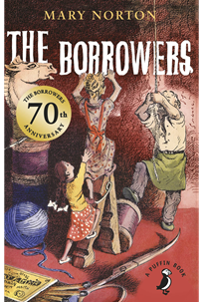
Languages
My Town
Where do you live?
In my Town
Counting in Tens
Counting in Hundreds
My address

