Phonics & Spellings Curriculum at Roundwood Primary School
Phonics & Spelling Journey
Early Years
At Roundwood Primary School, we follow Pearsons Bug Club Phonics scheme.
Focus / Order of  sounds taught | Set | Books
 | 1 –  2 |  | 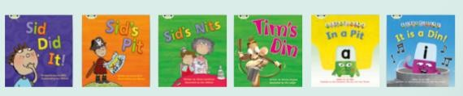
s / a / t / p
/ i / n / m /
d
 | 3 |  | 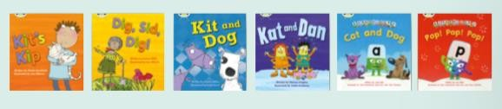
g / o / c /
k
 | 4 |  | 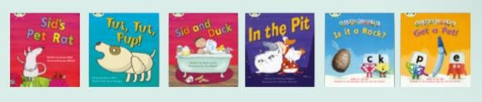
ck / e / u / r
 | 5 |  | 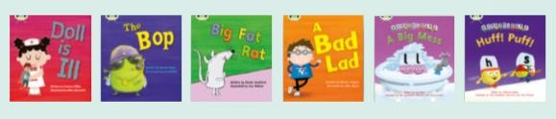
h / b / f /
ff / l / ll / ss
 | 6 |  | 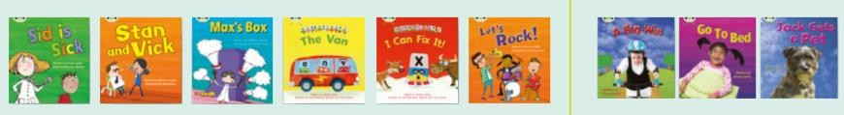
j / v / w / x
 | 7 |  | 
y / z / zz /
qu
 | 8 |  | 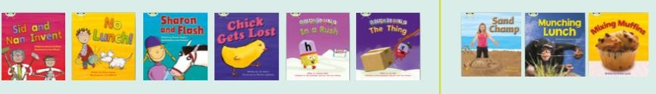
ch / sh / th /
ng
 | 9 |  | 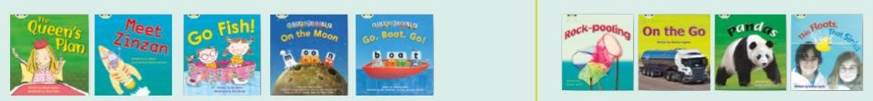
ai / ee / igh
/ oa / oo

ar / or / ur / ow / oi | 10 |  | 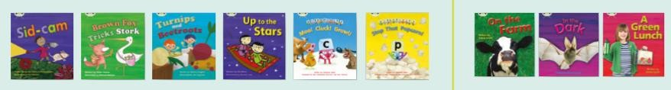
ear / air / ure  / er | 11 |  | 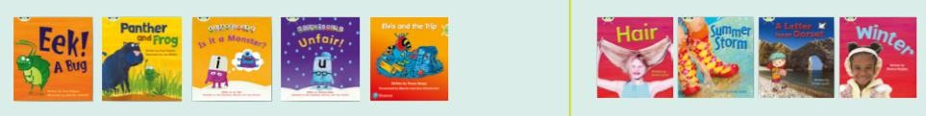
Consolidation of above | 12 |  | 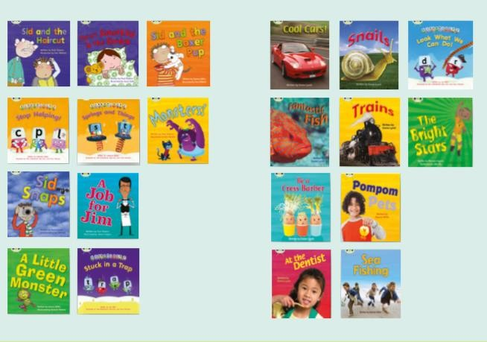
In Year 1
Focus / Order of sounds taught | Set | Books
zh / wh / ph | 13 |  | 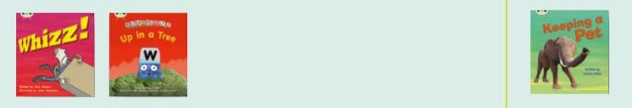
ay / a-e / ey / ei (long a) | 14 |  | 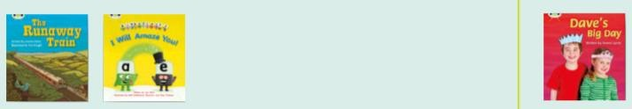
ea / e-e / ie  / ey / y (long e) | 15 |  | 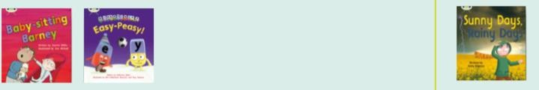

ie / i-e / y / i  (long i) | 16 |  | 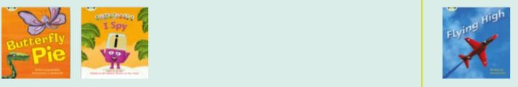
ow / o-e / o / oe  (long o) | 17 |  | 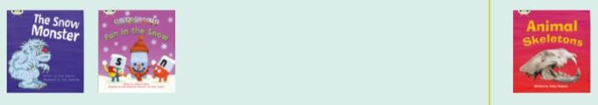
ew / ue / u-e (long u)  u / oul (short oo) | 18 |  | 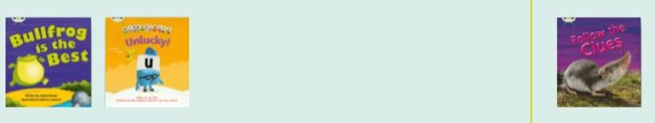
aw / au / al | 19 |  | 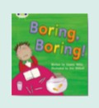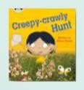
ir / er / ear | 20 |  | 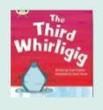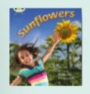
ou / oy | 21 |  | 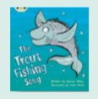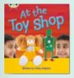
eer / ere / are /ear | 22 |  | 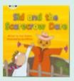
c / k / ck / ch | 23 |  | 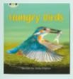
ce / ci / cy / sc / stl / se | 24 |  | 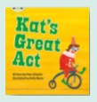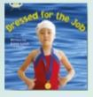

ge / gi / gy / dge | 25 |  | 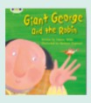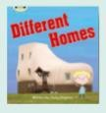
le / mb / kn / gn / wr | 26 |  | 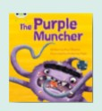
tch / t(ion) / ss(ion) /  c(ial) / ea / wa  / o | 27 |  | 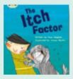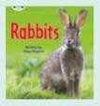
In Year 1
In addition to their phonics learning, children are taught how adding -ing, -ed, -er and -est changes how a word
is read and changes its meaning. They look at plurals, adding -s and -es to singular words. Children are also introduced to the prefix un- and explore how this changes the meaning of root words.
In Year 2
As children approach the end of Key Stage One, they have a secure understanding of the phonics phases one
– five. Alongside this, they are learning to spell more words with contracted forms, learning the possessive apostrophe and distinguishing between homophones and near-homophones to help them read words. As well as this, they are introduced to words which have added suffixes including –ment, –ness, –ful, –less, –ly.
In Year 3
By now, our children are confident in using their phonetic knowledge to decode words automatically.
From being taught how to recognise root words in their spelling lessons, they are able to use their growing knowledge of root words and pre-fixes including: in-, im-, il-, ir-, dis-, mis-, un-, re-, sub-, inter-, super-, anti- and auto- to help them read words.
They are also taught common exception words including words that do not follow spelling patterns.
In Year 4
By now, our children can use their understanding of root words, prefixes (including re-, sub-, inter-, super-, anti-
and auto-) and suffixes (including -ation and -ous) to help them to read words. By the end of Year 4, children can read and decode all common exception words accurately, including words that do not follow spelling patterns.
In Year 5
Our children will continue to use a growing knowledge of root words, prefixes, suffixes and word endings. They will understand how spelling rules (including words ending in -ably and -ibly, -ance/-ancy, -ence/ency, turning adjectives into adverbs, converting nouns and adjectives into verbs and homophones/near homophones) help
them to read words. By the end of Year 5, children can read fluently and with increasing speed and skill.
In Year 6
Our children will use and apply a growing knowledge of root words, prefixes, suffixes and word endings. They will understand how spelling rules (including words ending in -gue and que-, “ch” making the “k” and “sh” sound, “ou” as in “u”, -able and -ible endings, -ible and -ibly endings, “ei”, “eigh” and “ey”;”ea” and “aigh” sounds and “s” spelled “sc”) help them to read words aloud and understand the meaning of new words they meet. In Year 6,
children can read fluently and with increasing speed and skill.

Because I went to RPS
- I can recognise all phonemes and graphemes
- I can blend and segment phonemes and graphemes
- I can read all common exception words
- I can read words automatically and without undue hesitation
- I can use a range of spelling strategies to help me to identify, read and spell new words
- I can spot spelling rules and use this learning to help me to read new words
- I can use the spelling strategies linked to visual techniques, mnemonics, rule-based learning and word-meaning so that when I read new words, it becomes automatic and instinctive

