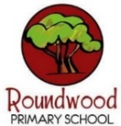
Year 1 – Spring 2
These activities are designed to give you some ideas of activities to do at home with your families or independently, to support your learning at school. Please choose TWO TASKS to complete this half term. Bring things in to share as and when you have done them. We can’t wait to see your creativity!
Science - Seasonal Changes – Spring  Go for a walk and see which signs of spring that you can see. You might want to draw them or take photos of the things you see. | English  Write a list poem – here are some ideas  - about things that you might have lost or found  - things that are connected to the season of spring  - different types of weather  Which describing words can you use to describe the items in your list? E.g.  A sticky sweet down the back of the chair  A shiny marble at the bottom of the toy box  One stripy sock down the side of my bed | Maths - Numbers to 20  - Play games that involve rolling two dice and practice adding the two numbers together.  - Use some raffle tickets, or write some numbers on cards. Can you order them from smallest to largest, largest to smallest or use < and > to compare them? | Art - 3D Paper sculptures  Create a 3D sculpture using paper and card. How can you shape, fold, twist or build with your paper?  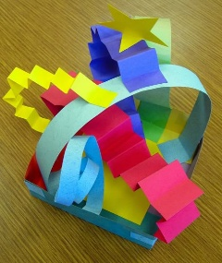  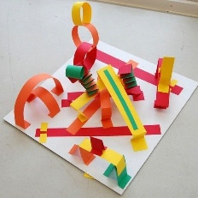  Photograph or bring in your sculpture for us to see.
 | Geography – Oceans and Continents  Find out about a country within one of the continents of the world where the weather is really hot, or a place that is really cold. | PSHCE – Rights and Responsibilities  Could you do a job around the house to earn some wages? What could you use your wages for – to buy something or save up for something more expensive. | Future Me – Play a memory game  This could be a card one where you find pairs that match.  Or you could play Kim’s game where you collect different objects and try to remember them all. One person then removes an item and you have to guess which is missing. Start with a few items and increase the amount as you get better.

