
Year 1 – Spring 1
These activities are designed to give you some ideas of activities to do at home with your families or independently, to support your learning at school. Please choose two to complete this half term. Bring things in to share as and when you have done them. We can’t wait to see your creativity!
Animals including humans  - Make a collection of animals and sort them according to whether they are carnivores, herbivores or omnivores.  - Complete a fact file about an animal of your choice. | English - Write a letter to someone you know  - to say thank you for a Christmas present  - to tell them about something you have been doing  - to ask them about what they have been doing recently  - to ask a question about something you want to know about  - to ask their opinion about something | Maths - Numbers to 20  Choose a number between 11 and 20.  - How can you represent that number in different ways?  - Which calculations can you write that make that number? | 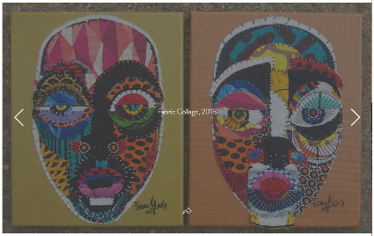  Art -  Brianna McCarthy makes collages of faces using different lines and patterns. Draw an outline of a face. Divide it into different sections and fill each one with different lines, patterns and colours. You could do a collage with different papers or fabrics too.
DT – Textiles  - Practise threading a needle and tying a knot in the end.  - Can you join pieces of fabric together with some stitches?  - If you are feeling adventurous, you could make a picture using and joining different pieces of fabric. | History - The Great Fire of London  - Make a model of a house that may have existed at this time.  - Make a collage of the Fire of London with the silhouette of London in the foreground. | PSHCE – Keeping Myself Safe  - In PSHCE we will be talking about ways to keep ourselves safe in different situations  - Talk with your grown-ups about ways that you can keep yourself self at home.  - Make a poster to highlight dangers in the home and how to keep yourself safe. | Future Me – How to thread a needle  - There will be many situations when threading a needle for sewing will be needed and so this is an important life skill  - Throughout school there will be different textiles projects where threading a needle for sewing will be needed.  - Practice with different sized needles.  - Can you sew on a button or sew up a hole in a sock?

